Chapter 12 – 1 First Derivative and Graphs

A partition number for a function of x is a value at which the function is zero or undefined. Partition numbers for a function divide the domain of the function into subintervals over which the function has the same sign (i.e., it is always positive or it is always negative).
If a value is in the domain of a function and is a partition number for the derivative of the function, it is called a critical value of the function. Critical values divide the domain of the function into subintervals over which the function is always increasing (positive derivative) or decreasing (negative derivative).
Given a function f(x), f(c) is a local maximum if there exists an interval (m, n) containing c for which f(c) ≥ f(x) for all x in the interval (m, n). Over its domain, a function may have zero, one, or more local maxima.

Similarly, f(c) is a local minimum if there exists an interval (m, n) containing c for which f(c) ≤ f(x) for all x in the interval (m, n). Over its domain, a function may have zero, one, or more local minima.

The value, f(c), is a local extremum if it is either a local maximum or a local minimum. Over its domain, a function may have zero, one, or more local extrema.

Local extrema occur at critical values of the function (i.e., where the derivative is zero or undefined).

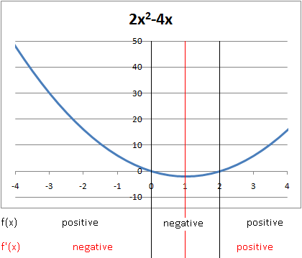
For the following problems, find the partition numbers and the critical values and determine where the function is positive and where it is negative and where it is increasing and where it is decreasing and the local extrema.
Example 1. $f\left(x\right)=2x^{2}-4x$
Partition numbers:
$f\left(x\right)=0 ⟹ x=0, x=2$
$f\left(x\right)\text{ is always defined.}$

Critical values:
$f^{'}\left(x\right)=4x-4=0 ⟹ x=1$
$f'\left(x\right)\text{ is always defined.}$

Local Minimum: at $x=1, f\left(1\right)=-2.$ This is also the absolute minimum.

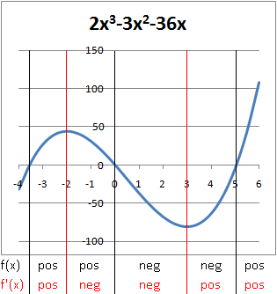
Example 2. $f\left(x\right)=2x^{3}-{3x}^{2}-36x$
Partition numbers:
$f\left(x\right)=0 ⟹ x=0, x≈-3.558, x≈5.058$
$f\left(x\right)\text{ is always defined.}$

Critical values:
$f^{'}\left(x\right)=6x^{2}-6x-36=0 ⟹ x=-2, x=3$
$f'\left(x\right)\text{ is always defined.}$

Local Maximum: at $x=-2, f\left(-2\right)=44$
Local Minimum: at $x=3, f\left(3\right)= -81$

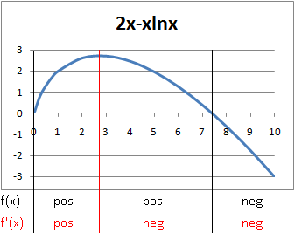
Example 3. $f\left(x\right)=2x-x\ln{x}$
Partition numbers:
$f\left(x\right)=0 ⟹ x=0, x=e^{2}≈7.389$
$f\left(x\right)\text{ is defined on the open interval (0, ∞).}$

Critical values:
$f^{'}\left(x\right)=1-\ln{x}=0 ⟹ x=e≈2.718$
$f'\left(x\right)\text{ is defined on the open interval (0, ∞).}$

Local Maximum: at $x=e, f\left(e\right)=e$. This is also the absolute maximum.

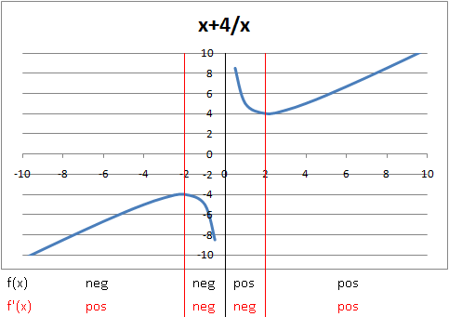
Example 4. $f\left(x\right)=x+\frac{4}{x}$
Partition numbers:
$f\left(x\right) is undefined at x=0$
$f\left(x\right)\text{ is defined on (}-\text{∞, 0) and (0, ∞).}$

Critical values:
$f^{'}\left(x\right)=1-\frac{4}{x^{2}}=0 ⟹ x=±2$
$f'\left(x\right)\text{ is defined on (}-\text{∞, 0) and (0, ∞).}$

Local Maximum at $x=-2, f\left(-2\right)=-4$
Local Minimum at $x=2, f\left(2\right)=4$

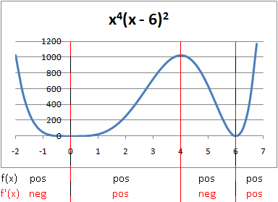
Example 5. $f\left(x\right)=x^{4}{\left(x-6\right)}^{2}$
Partition numbers:
$f\left(x\right)=0 ⟹ x=0, x=6$
$f\left(x\right)\text{ is defined everywhere.}$

Critical values:
$f^{'}\left(x\right)=6x^{3}\left(x-6\right)\left(x-4\right)=0 ⟹ x=0, x=4, x=6$
$f'\left(x\right)\text{ is defined everywhere.}$

Local Maximum at $x=4, f\left(4\right)=1024$
Local Minimum at $x=0, f\left(0\right)=0.\text{ This is also an absolute minimum.}$
Local Minimum at $x=6, f\left(6\right)=0.\text{ This is also an absolute minimum.}$

