# Chapter 12 – 2 Second Derivative and Graphs

The **second derivative** of the function $y=f\left(x\right)$ is the derivative of the derivative of the function:

$$f^{''}\left(x\right)=\frac{d}{dx}f^{'}\left(x\right)=\frac{d^{2}y}{dx^{2}}=y''$$

The graph of a function is **concave upward** (or **concave up**) at a point $x=c$ if there exists an interval $(m,n)$ containing $c$ for which the graph of $f\left(x\right)$ lies above the tangent to the graph of $f(x)$ at $x=c$. If the second derivative of a function is positive at $x=c$ then the graph is concave upward at $x=c$. Using a bowl as an analogy, when the bowl is concave up it will hold water.

The graph of a function is **concave downward** (or **concave down**) at a point $x=c$ if there exists an interval $(m,n)$ containing $c$ for which the graph of $f\left(x\right)$ lies below the tangent to the graph of $f(x)$ at $x=c$. If the second derivative of a function is negative at $x=c$ then the graph is concave downward at $x=c$. Using a bowl as an analogy, when the bowl is concave down it will not hold water.

An **inflection point** is a point on the graph of a function at which the concavity changes (i.e., the sign of the second derivative changes). If a function has an inflection point at $x=c$ then $f^{''}\left(c\right)=0$ or $f^{''}(c)$ does not exist (i.e., $x=c$ is a partition number of the second derivative function). The graph of the function lies above the tangent at $x=c$ on one side of an inflection point and below the tangent on the other side.

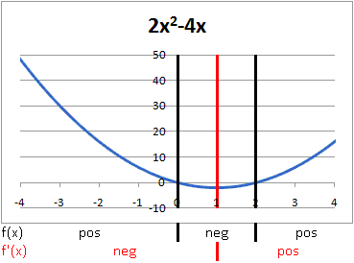**Example 1. $f\left(x\right)=2x^{2}-4x$**

Partition numbers:

$f\left(x\right)=0 ⟹ x=0, x=2$

Critical values:

$f^{'}\left(x\right)=4x-4=0 ⟹ x=1$

Local Minimum: at $x=1, f\left(1\right)=-2.$ This is also the absolute minimum.

Concavity:

$f^{''}\left(x\right)=4 ⟹$ The graph of $f(x)$ is always concave up.

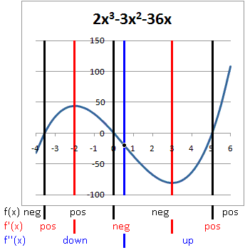**Example 2. $f\left(x\right)=2x^{3}-{3x}^{2}-36x$**

Partition numbers:

$f\left(x\right)=0 ⟹ x=0, x≈-3.558, x≈5.058$

Critical values:

$f^{'}\left(x\right)=6x^{2}-6x-36=0 ⟹ x=-2, x=3$

Local Maximum: at $x=-2, f\left(-2\right)=44$

Local Minimum: at $x=3, f\left(3\right)= -81$

Concavity:

$f^{''}\left(x\right)=12x-6=6\left(2x-1\right)=0 ⟹ x=\frac{1}{2}$

The graph has an inflection point at $x=\frac{1}{2}$

The graph is concave down on $\left(-∞,\frac{1}{2}\right)$ and concave up on $\left(\frac{1}{2},∞\right)$

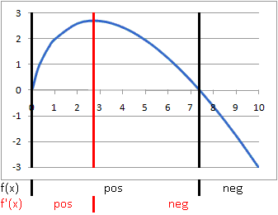**Example 3. $f\left(x\right)=2x-x\ln{x}$**

Partition numbers:

$f\left(x\right)=0 ⟹ x=0, x=e^{2}≈7.389$

The domain of $f(x)$ is $\left(0,∞\right)$

Critical values:

$f^{'}\left(x\right)=1-\ln{x}=0 ⟹ x=e≈2.718$

Local Maximum: at $x=e, f\left(e\right)=e$. This is also the absolute maximum.

Concavity:

$f^{''}\left(x\right)=-\frac{1}{x} ⟹ f\left(x\right)$ is always concave down.

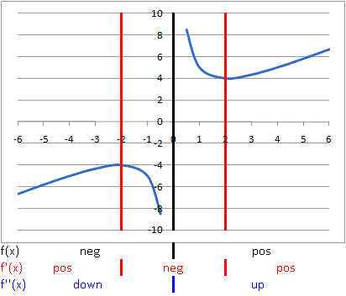**Example 4. $f\left(x\right)=x+\frac{4}{x}$**

Partition numbers:

$f\left(x\right) is undefined at x=0$

$f\left(x\right)\text{ is defined on (}-\text{∞, 0) and (0, ∞).}$

Critical values:

$f^{'}\left(x\right)=1-\frac{4}{x^{2}}=0 ⟹ x=±2$

$f'\left(x\right)\text{ is defined on (}-\text{∞, 0) and (0, ∞).}$

Local Maximum at $x=-2, f\left(-2\right)=-4$

Local Minimum at $x=2, f\left(2\right)=4$

Concavity:

$f^{''}\left(x\right)=\frac{8}{x^{3 }} ⟹ f\left(x\right)$ is concave down on $\left(-∞,0\right)$ and concave up on $\left(0,∞\right)$.

There is no inflection point.

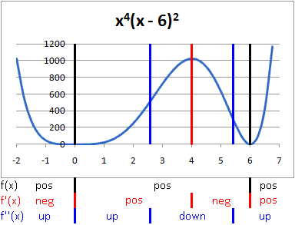**Example 5. $f\left(x\right)=x^{4}{\left(x-6\right)}^{2}$**

Partition numbers:

$f\left(x\right)=0 ⟹ x=0, x=6$

$f\left(x\right)\text{ is defined everywhere.}$

Critical values:

$f^{'}\left(x\right)=6x^{3}\left(x-6\right)\left(x-4\right)=0 ⟹ x=0, x=4, x=6$

$f'\left(x\right)\text{ is defined everywhere.}$

Local Maximum at $x=4, f\left(4\right)=1024$

Local Minimum at $x=0, f\left(0\right)=0.\text{ This is also an absolute minimum.}$

Local Minimum at $x=6, f\left(6\right)=0.\text{ This is also an absolute minimum.}$

Concavity:

$f^{''}\left(x\right)=6x^{2}\left(5x^{2}-40x+72\right)=0 ⟹ x=0, 4-\sqrt{2}, 4+\sqrt{2}$

Concave up on $\left(-∞,0\right), \left(0,4-\sqrt{2}\right), \text{and }\left(4+\sqrt{2},∞\right)$

Concave down on $\left(4-\sqrt{2}, 4+\sqrt{2}\right)$

Point of inflection at $x=4-\sqrt{2}\text{ and }x=4+\sqrt{2}$

Even though $f^{''}\left(0\right)=0$, there is no point of inflection at $x=0$. Since the function is neither concave up nor concave down at $x=0$, the function must be flat.

**Example 6.** The marketing research department of a computer company used a large city to test market the firm’s new product. The department found that the relationship between price p (dollars per unit) and the demand x (units per week) was given approximately by

$$p=1,296-0.12x^{2} 0<x<80$$

Find the revenue (as a function of demand) and then find the local extrema for the revenue function and the intervals on which the revenue function is concave up and the intervals on which the function is concave down.



$R\left(x\right)=xp=1,296x-0.12x^{3}$

Partition Numbers:

$R\left(x\right)=0 ⟹ x=0, x=±60\sqrt{3}$

There are no partition numbers for $R\left(x\right)$ on the interval $\left(0, 80\right).$

Critical Values:

$R^{'}\left(x\right)=1,296-0.36x^{2}=0 ⟹ x=±60$

Local maximum at $x=60 \text{where }R\left(60\right)=\text{ \$51,840}$

Concavity:

$R^{''}\left(x\right)=-0.72x ⟹ R\left(x\right)\text{ is always concave }\text{down }\text{on the interval }\left(0, 80\right)\text{.}$

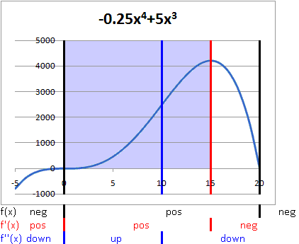**Example 7.** A T-shirt manufacturer is planning to expand its workforce. It estimates that the number of T-shirts produced by hiring x new workers is given by

$$T\left(x\right)=-0.25x^{4}+5x^{3} 0≤x≤15$$

When is the rate of change of T-shirt production increasing and when is it decreasing? What is the point of diminishing returns and the maximum rate of change of T-shirt production? Graph $T(x)$ and $T^{'}(x)$ on the same coordinate system.

Partition Numbers:



$T\left(x\right)=0 ⟹ x=0, x=20$

The only partition number on [0, 15] is $x=0$.

Critical Values:

$T^{'}\left(x\right)=-x^{3}+15x^{2}=0 ⟹ x=0, x=15$

Local maximum at $x=15 \text{where }T\left(15\right)=\text{ 4,218.75}$

Concavity:

$T^{''}\left(x\right)=-3x^{2}+30x=0$

There is a point of inflection at $x=0\text{ and at} x=10$.

The point of diminishing returns is at $x=10$. This is also the location of the maximum rate of change in T-shirt production per new employee at 500 T-shirts per new employee. This is also the location of an inflection point on the graph of total T-shirt production, $T\left(x\right).$