# Chapter 10 – 4b The Derivative

**Example 3.** The ozone level (in parts per billion) on a summer day in a metropolitan area is given by

$P\left(t\right)=80+12t-t^{2}$, $0≤t≤12$

where t is time in hours and t = 0 corresponds to 9 AM.

$$P^{'}\left(t\right)=\lim_{h→0}{\frac{P\left(t+h\right)-P(t)}{h}}$$

$$=\lim_{h→0}{\frac{\left[80+12\left(t+h\right)-{\left(t+h\right)}^{2}\right]-\left[80+12t-t^{2}\right]}{h}}$$

$$=\lim_{h→0}{\frac{\left[80+12t+12h-\left(t^{2}+2th+h^{2}\right)\right]-\left[80+12t-t^{2}\right]}{h}}$$

$$=\lim_{h→0}{\frac{\left[12h-2th-h^{2}\right]}{h}}=\lim_{h→0}\left(12-2t-h\right)=12-2t$$

B) Find the change in the ozone level from 9 AM to noon. Find the average rate of change over this same time interval. Find the instantaneous rate of change at 9 AM and at noon.

$ΔP=P\left(3\right)-P\left(0\right)=107-80=27$ parts per billion

$$\frac{ΔP}{Δt}=\frac{27 ppb}{3 hr}=9 ppb/hr$$

At 9 AM, $P^{'}\left(0\right)=12 ppb/hr$ and at noon, $P^{'}\left(3\right)=6 ppb/hr$.

C) Find the change in the ozone level from 4 PM to 7 PM. Find the average rate of change over this same time interval. Find the instantaneous rate of change at 4 PM and at 7PM.

$ΔP=P\left(10\right)-P\left(7\right)=100-115=-15$ ppb

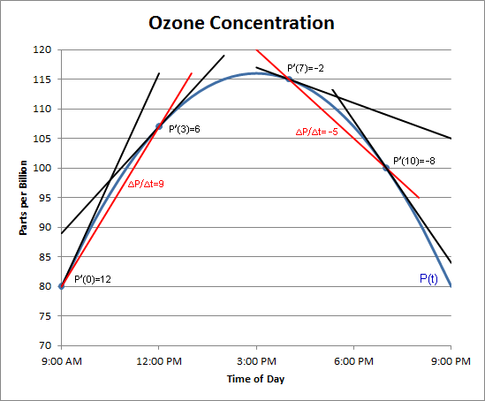

$$\frac{ΔP}{Δt}=\frac{-15 ppb}{3 hr}=-5 ppb/hr$$

At 4 PM, $P^{'}\left(7\right)=-2 ppb/hr$

At 7 PM, $P^{'}\left(10\right)=-8 ppb/hr$

**Example 4** The total sales of a company (in millions of dollars) from now until t months from now is estimated to be

$S\left(t\right)=2\sqrt{t+10}$, $0≤t≤36$

$$S^{'}\left(t\right)=\lim_{h→0}{\frac{S\left(t+h\right)-S(t)}{h}}$$

$$=\lim_{h→0}{\frac{2\sqrt{t+h+10}-2\sqrt{t+10}}{h}}$$

$$=\lim_{h→0}{\frac{2\left(\sqrt{t+h+10}-\sqrt{t+10}\right)}{h}∙\frac{\left(\sqrt{t+h+10}+\sqrt{t+10}\right)}{\left(\sqrt{t+h+10}+\sqrt{t+10}\right)}} \\ =\lim_{h→0}{\frac{2\left[\left(t+h+10\right)-\left(t+10\right)\right]}{h\left(\sqrt{t+h+10}+\sqrt{t+10}\right)}} \\ =\lim_{h→0}{\frac{2h}{h\left(\sqrt{t+h+10}+\sqrt{t+10}\right)}} \\ =\lim_{h→0}{\frac{2}{\sqrt{t+h+10}+\sqrt{t+10}}} \\ =\frac{2}{2\sqrt{t+10}} \\ =\frac{1}{\sqrt{t+10}}$$

Find S(15) and S’(15). Use S’(15) to estimate S(16) and S(17). Compare these estimates to the values given by the function.

$$S\left(15\right)=2\sqrt{15+10}=2\sqrt{25}=10\text{ million dollars} \\ S^{'}\left(15\right)=\frac{1}{\sqrt{15+10}}=\frac{1}{\sqrt{25}}=0.2\text{ million dollars per month}\text{ or \$200,000/month}$$ $$S\left(16\right)≈S\left(15\right)+1∙S^{'}\left(15\right)=10+1∙0.2=10.2\text{ million dollars} \\ S\left(16\right)=2\sqrt{16+10}=2\sqrt{26}≈10.198\text{ million dollars} \\ Error≈{\left(10.2-10.198\right)}/{10.198}=0.02\%$$ $$S\left(17\right)≈S\left(15\right)+2∙S^{'}\left(15\right)=10+2∙0.2=10.4\text{ million dollars} \\ S\left(17\right)=2\sqrt{17+10}=2\sqrt{27}≈10.392\text{ million dollars} \\ Error≈{\left(10.4-10.392\right)}/{10.392}=0.07\%$$